
Phone No: 9906457756
Fax: : 0194-2310144
OFFICE OF THE PRINCIPAL,
KASHMIR GOVT. POLYTECHNIC COLLEGE GOGJI BAGH SRINAGAR.
Web: http://www.kgpsrinagar.edu.in.
Email: kgpolysgr58@gmail.com

IMPORTANT NOTICE FOR STUDENTS
Subject: Mandatory Enrollment in Pradhan Mantri Suraksha Bima Yojana (PMSBY) – Accident Insurance Scheme from J&K Bank, as Mandated by AICTE.
In order to ensure your safety and financial security against unforeseen accidents for students, and as mandated by the All-India Council for Technical Education (AICTE), the institution is facilitating enrollment in the Pradhan Mantri Suraksha Bima Yojana (PMSBY), an Accident Insurance Scheme offered by J&K Bank. This scheme provides comprehensive coverage for accidental death and disability, offering peace of mind to you and your family.
Salient Features of the Scheme:
- On Death due to Accident: The nominee shall receive Rs. 2 Lakhs.
- Total and Irrecoverable Loss of Both Eyes, or Loss of Use of Both Hands or Feet, or Loss of Sight of One Eye and Loss of Use of One Hand or Foot: The subscriber shall receive Rs. 2 Lakhs.
- Total and Irrecoverable Loss of Sight of One Eye, or Loss of Use of One Hand or Foot: The subscriber shall receive Rs. 1 Lakh.
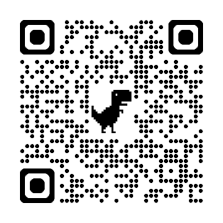
This is a mandatory requirement for all students, as per AICTE guidelines. You are required to submit your personal details immediately to activate your coverage under this scheme.
How to Submit Your Details:
- Fill out the details in the provided Google Form Link https://forms.gle/mzpxaUcLU6eWN2ir5
Alternatively, scan the QR Code and complete the form instantly.

Note: Ensure all details are accurate and complete. Incomplete submissions will not be processed, and coverage will not be activated. The deadline for submission is
15-11-2025. For any queries, contact on 9906457756.

No: KGP/Estt/2025/1595
Dated:13-11-2025

Principal
Kashmir Government Polytechnic College
Srinagar.

Copy to the:
- All HoD’s/Incharges for information with the directions to ensure that all students upload their details on the given Google form.
- Establishment Section for information and necessary action.

